



Venus: MFANZ
Issue Resolution Procedures

Author: Peter Smith
Creation Date: 28 February, 2005 09:02
Last Updated: Friday, 30 November 2007
Version: Draft

Notice of Confidentiality
This document and the information contained in it are the property of Information Services International and MFANZ. They may not in any way be disclosed, copied or used by anyone except as expressly authorized by ISI and/or MFANZ. The document should always be kept in a secure place and should be destroyed or returned to ISI when it is no longer needed.

Table of Contents

Issue Resolution Procedures 3
Scenario #01: Missing Invoice Summary 3
Resolution Overview 3
Resolution Steps 4
Resolution Overview 6
Appendix 11
Invoice Invoice / Invoice Summary Reconciliation Sql 11
Display INVALID invoices by Company Code and Creation Date 13
Display invoices (and SMY Value) by Sales Organization and Creation Date 14
SQL to Check Invalid Invoices 15

Issue Resolution Procedures

Scenario #01: 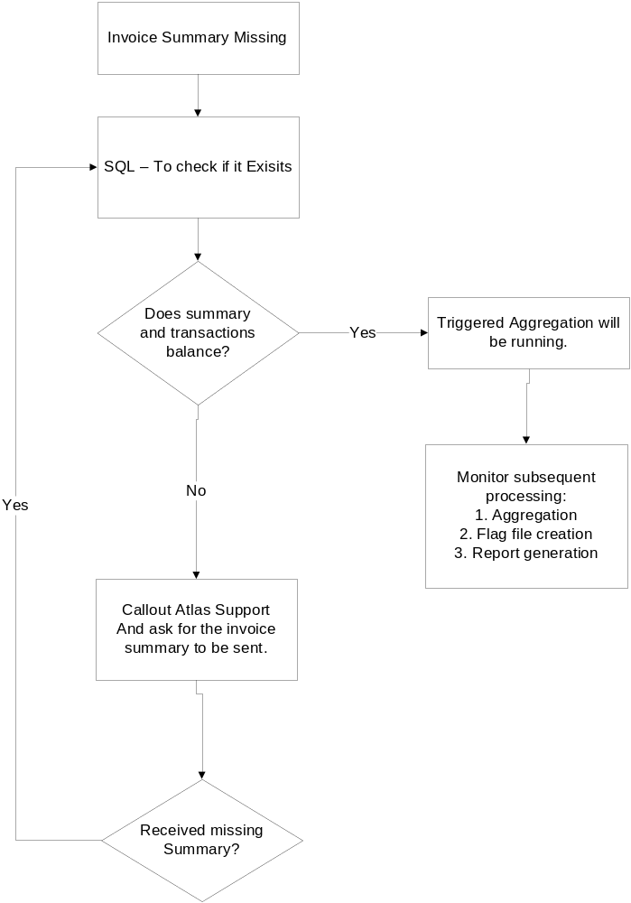Missing Invoice Summary

Resolution Overview

Resolution Steps

Prerequisite Steps / Notes

Ensure that the following steps / notes are considered:

Document all steps in the process.
Record contact times with the ART, Atlas Support Team, etc.
Ensure that VPN (Inbound) is available, support portable, etc is available.
Ensure you have access to the MFANZ CDW ICS website.
Ensure all relevant accounts/passwords are known.

Invoice Summary Missing

Invoice Summary Missing trigger Tivoli alerts, resulting in a callout to the MFANZ CDW Support team, as per the details in the Support Contact Directory.

In conjunction with the callout, an email note is sent to the MFANZ CDW Support team.

Run Manual SQL Reconciliation (company, creation date)

Using ODS_APP to access the production database, AP0070P, run the SQL to check if the invoice summary has arrived.

- Select * from sap_inv_sum_hdr Order by fkdat desc

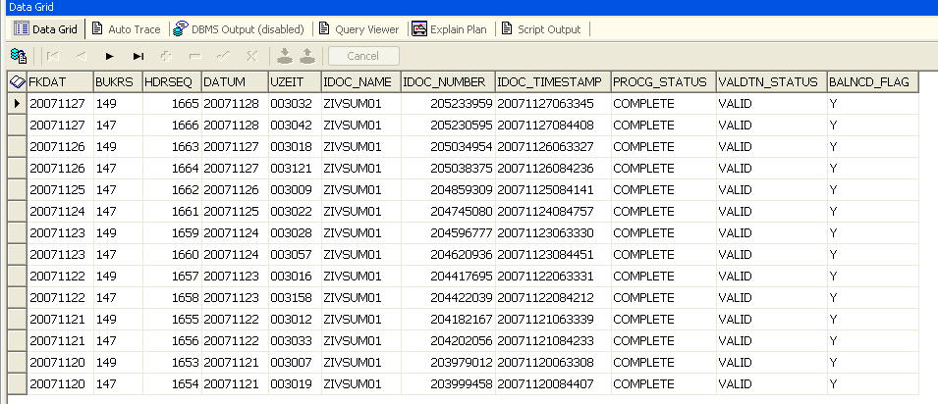
Invoice Create Date
IDOC Create Date

Run Manual SQL Reconciliation (company, creation date)

Run this SQL to check what invoices exisit in the system.

The SQL can be found in the MFANZ Atlas Info Delivery lotus notes database, however a copy is included in the Appendix, in the section titled: Invoice Invoice / Invoice Summary Reconciliation SQL.

Callout Atlas Support

If an imbalance exists, and there are no applicable invalid invoices in the data warehouse, then it is most likely that there is one or more invoices which have not been sent from Atlas to the data warehouse.

Therefore, Atlas Support is contacted; - Details can be found on the support contact directory.

Note that the following will (probably) have to be supplied:

A copy of the invoice summary reconciliation details.
A list of invoices for the relevant creation date.

A list of invoices for a Company Code and Creation Date can be found using the Display Invoices (And SMY Value) By Sales Organization And Creation Date SQL in the Appendix.

Monitor subsequent processing:

If issues have occurred in aggregations, it is worth monitoring the processing to ensure that there are no downstream issues caused by the delay in aggregation processing. This includes the following:

Aggregation: ensure that aggregations complete successfully. The Processing Status of the aggregation header record should be COMPLETE and the Validation Status should be VALID.
Flag File Creation: the flag file should have been created and sent to the Business Objects server (APVN60).
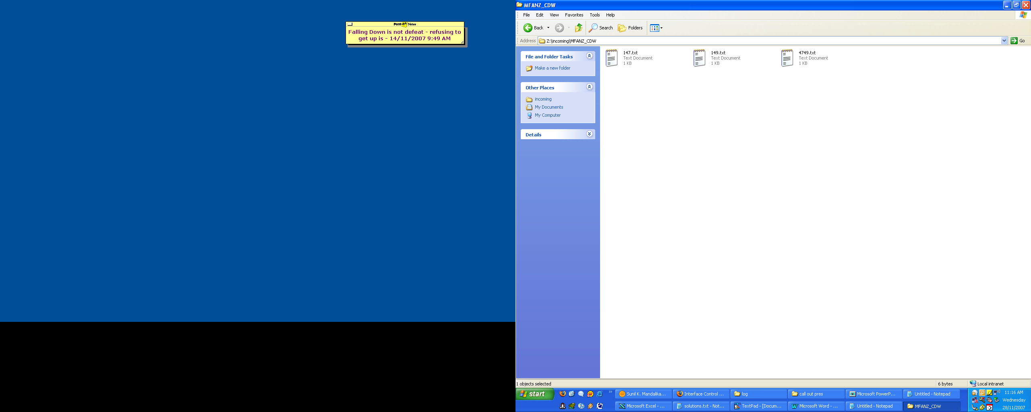

Report Generation: ensure that the reports are processing as expected, using APOS to see that they are running.
Scenario #02: Invoice Summary Imbalance

Resolution Overview

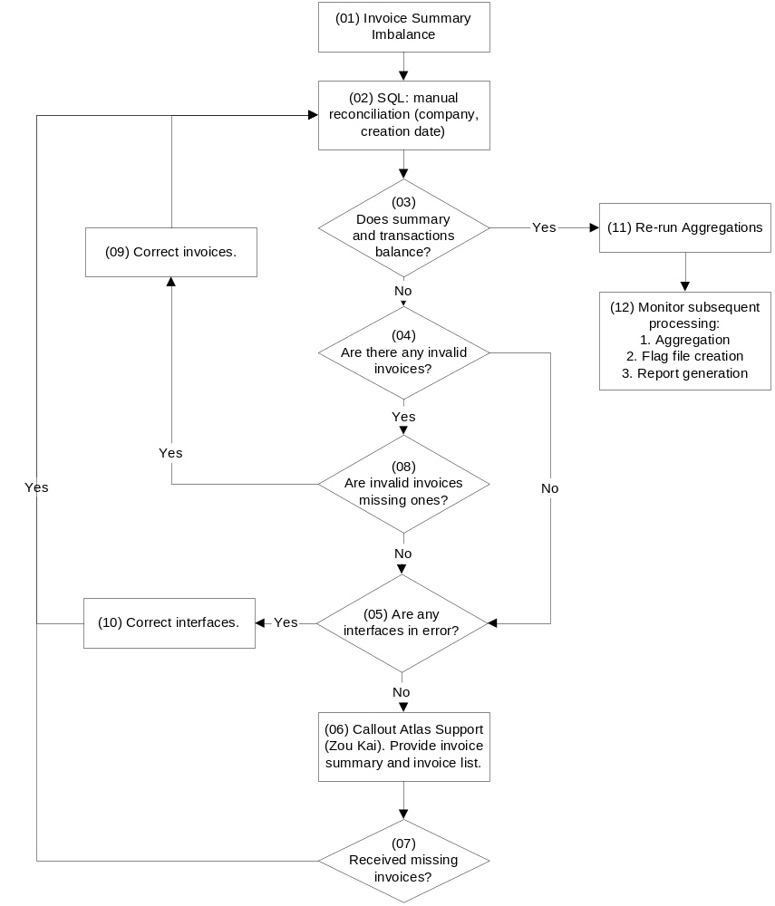

Invoice Summary Imbalance

Invoice Summary Imbalances trigger Tivoli alerts, resulting in a callout to the MFANZ CDW Support team, as per the details in the Support Contact Directory.

In conjunction with the callout, an email note is sent to the MFANZ CDW Support team, as per the following example (which comes from the test system AP0066T):

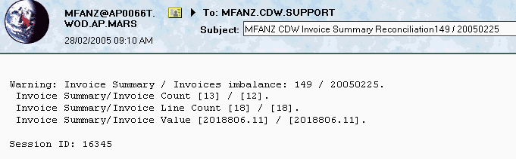

Run Manual SQL Reconciliation (company, creation date)

Using ODS_APP to access the production database, AP0070P, run a manual reconciliation of invoice transactions to the invoice summary. Ensure that the Company Code and Creation Date (usually the prior day's date) are entered correctly. The SQL can be found in the MFANZ Atlas Info Delivery lotus notes database, however a copy is included in the Appendix, in the section titled: Invoice Invoice / Invoice Summary Reconciliation SQL.

Does Summary and Transactions Balance?

After running the reconciliation SQL, check whether the summary balances to the invoices.

There have been instances in the past, where the transactions have simply been late, so that by the time the callout has been received, and the system checked, all the necessary transactions have been received.

Are There Any Invalid Invoices?

This steps determines whether there are any invalid invoices, which may be contributing to the imbalance between the Invoice Summary and the invoice transactions in the ODS.

A copy of the required SQL is included in the Appendix, in the section titled: Display Invalid Invoices By Company Code and Creation Date.

Are Any Interfaces In Error?

Using the MFANZ CDW ICS website, check to see whether any interfaces are in error. There are numerous reasons for failed interfaces, and some of the most-likely causes are specified below:

Database Space Issues: check whether the error messages are due to tablespace, archive log space or other disk capacity related issues.
Structure Changes: changes to the interface message structure, whilst much less likely an occurrence, can occur in the Atlas and/or the AMI Hub parts of the interface processing.

Callout Atlas Support

If an imbalance exists, and there are no applicable invalid invoices in the data warehouse, then it is most likely that there is one or more invoices which have not been sent from Atlas to the data warehouse.

Therefore, Atlas Support is contacted; - Details can be found on the support contact directory.

Note that the following will (probably) have to be supplied:

A copy of the invoice summary reconciliation details.
A list of invoices for the relevant creation date.

A list of invoices for a Company Code and Creation Date can be found using the Display Invoices (And SMY Value) By Sales Organization And Creation Date SQL in the Appendix.

Received Missing Invoices?

Once Atlas Support have been contacted, you will have to wait until they determine which invoices are missing, and then they send those invoices to the data warehouse. Check whether the invoice batch(es) has arrived using the MFANZ ICS CDW website, or checking for the specific invoices in the SAP_INV_HDR table.

Are Invalid Invoices Missing Ones?

This step involves checking whether any invalid invoices contribute to the reconciliation issue. The reasons which can cause an invoice to become invalid are numerous, and therefore, make the checking process less prescriptive, however, ensure the following checks are recommended:

Re-run the reconciliation SQL, removing from the WHERE clause of the SQL the line which limited the Invoice Validation Status (valdtn_status) to valid. If the summary now balances to the transactions, you know for sure that it is due to one or more invalid invoices.
Check whether any invoices exist (SAP_INV_DAT) which do not have an Invoice Creation Date (QUALF = '015'). This covers the instance where the invoice was received, but the data warehouse cannot attribute to the correct summary, due to a missing date type record.

Correct invoices.

Once invalid invoices are identified, the conditions that cause the invoices to be invalid must be corrective. Once again, there are not prescriptive steps to doing this, and are dependent on the factors causing the issue.

The resolution process will generally fall into one of two categories:

Atlas Resend: Atlas will resend the invoice(s) in error once they fix the root-cause data issue.
Invoice Updated in CDW: firstly note that this is a situation to be avoided where possible, as it can cause numerous issues (reconciliation issues, manual fixes overwritten when resends occur, etc). There may be instances where transactions are manually updated in the data warehouse to ensure that transactions are valid.

Correct Interfaces.

Invoices interface issues are corrected in a manner appropriate to the root cause of the issue. This may be done via an increased disk allocation etc. If structural interface issues exist, the Development Team may need to be contacted to help rectify the issue.

Re-run Aggregations.

Once all root cause issues have been corrected, and the invoice summary balances with the invoice transactions, aggregations can be rerun. There are two ways in which aggregations can be rerun:

Website: the MFANZ CDW ICS website can be used to re-aggregate. Simply choose the Aggregation Reprocessing option, select the desired Company Code and Creation Date from the drop down list, and reprocess.
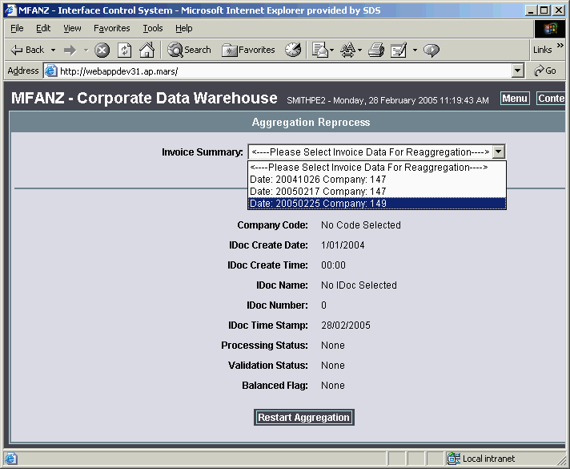
Manually: only follow these steps if aggregation processing, including all the status changes are intimately understood. Change the processing status of the invoice summary header to LOADED, change the validation status to UNCHECKED, commit the changes, and then suspend and restart the background processing jobs via the MFANZ CDW ICS website.
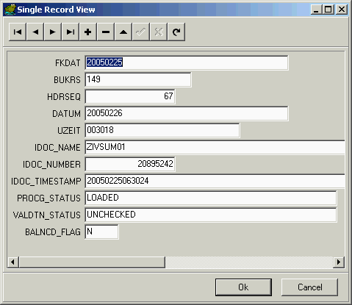

Monitor subsequent processing:

If issues have occurred in aggregations, it is worth monitoring the processing to ensure that there are no downstream issues caused by the delay in aggregation processing. This includes the following:

Aggregation: ensure that aggregations complete successfully. The Processing Status of the aggregation header record should be COMPLETE and the Validation Status should be VALID.
Flag File Creation: the flag file should have been created and sent to the Business Objects server (APVN60).

Report Generation: ensure that the reports are processing as expected, using APOS to see that they are running.

Appendix

Invoice Invoice / Invoice Summary Reconciliation Sql

-----------------------------------------------------------------
-- INVOICE / INVOICE SUMMARY RECONCILIATION SQL
-----------------------------------------------------------------
SELECT
creation_date,
company_code,
SUM(summ_count) AS summ_count,
SUM(summ_line) AS summ_line,
SUM(summ_value) AS summ_value,
SUM(trans_count) AS trans_count,
SUM(trans_line) AS trans_line,
SUM(trans_value) AS trans_value
FROM
(SELECT
a.fkdat AS creation_date,
a.bukrs AS company_code,
b.znumiv AS summ_count,
b.znumps AS summ_line,
b.netwr AS summ_value,
0 AS trans_count,
0 AS trans_line,
0 AS trans_value
FROM
sap_inv_sum_hdr a,
sap_inv_sum_det b
WHERE
a.fkdat = b.fkdat
AND a.bukrs = b.vkorg
AND a.bukrs = :i_company_code
AND a.fkdat = :i_creation_date
UNION ALL
SELECT
t1.datum AS creation_date,
t1.orgid AS company_code,
0 AS summ_count,
0 AS summ_line,
0 AS summ_value,
SUM(trans_count) AS trans_count,
SUM(trans_line) AS trans_line,
SUM(trans_value) AS trans_value
FROM
(SELECT
b.datum AS datum,
c.orgid AS orgid,
count(*) AS trans_count,
0 AS trans_line,
0 AS trans_value
FROM
sap_inv_hdr a,
sap_inv_dat b,
sap_inv_org c
WHERE a.valdtn_status = 'VALID' -- ods_constants.valdtn_valid
AND a.belnr = b.belnr
AND a.belnr = c.belnr
AND b.iddat = '015' -- ods_constants.invoice_document_date -- Document Date
AND b.datum = :i_creation_date
AND c.qualf = '008' -- ods_constants.invoice_sales_org -- Sales Organisation
AND c.orgid = :i_company_code
GROUP BY
b.datum,
c.orgid
UNION
SELECT
b.datum AS datum,
c.orgid AS orgid,
0 AS trans_count,
count(*) AS trans_line,
0 AS trans_value
FROM
sap_inv_hdr a,
sap_inv_dat b,
sap_inv_org c,
sap_inv_gen d
WHERE a.valdtn_status = 'VALID' -- ods_constants.valdtn_valid
AND a.belnr = b.belnr
AND a.belnr = c.belnr
AND a.belnr = d.belnr
AND b.iddat = '015' -- ods_constants.invoice_document_date -- Document Date
AND b.datum = :i_creation_date
AND c.qualf = '008' -- ods_constants.invoice_sales_org -- Sales Organisation
AND c.orgid = :i_company_code
GROUP BY
b.datum,
c.orgid
UNION
SELECT
b.datum AS datum,
c.orgid AS orgid,
0 AS trans_count,
0 AS trans_line,
SUM(DECODE(sign(instr(d.summe,'-',1,1)),1,-1,1) * trim('-' from d.summe)) AS trans_value
FROM
sap_inv_hdr a,
sap_inv_dat b,
sap_inv_org c,
sap_inv_smy d
WHERE a.valdtn_status = 'VALID' -- ods_constants.valdtn_valid
AND a.belnr = b.belnr
AND b.iddat = '015' -- ods_constants.invoice_document_date -- Document Date
AND b.datum = :i_creation_date
AND a.belnr = c.belnr
AND c.qualf = '008' -- ods_constants.invoice_sales_org -- Sales Organisation
AND c.orgid = :i_company_code
AND a.belnr = d.belnr
AND d.sumid = '010' -- ods_constants.invoice_smy_qualifier -- Get SMY values to balance to summary
GROUP BY
b.datum,
c.orgid) t1
GROUP BY
t1.datum,
t1.orgid)
GROUP BY
creation_date,
company_code

Display INVALID invoices by Company Code and Creation Date

------------------------------------------------------------------
-- ODS: Display INVALID invoices by Company Code and Creation Date
------------------------------------------------------------------
SELECT
c.orgid AS CompanyCode,
b.datum AS CreationDate,
a.belnr AS InvoiceNumber,
d.summe AS ReconciliationValue,
a.curcy AS Currency
FROM
sap_inv_hdr a,
sap_inv_dat b,
sap_inv_org c,
sap_inv_smy d
WHERE
a.valdtn_status = 'INVALID' AND
a.belnr = b.belnr
AND a.belnr = c.belnr
AND b.iddat = '015' -- Posting Date local time
AND c.qualf = '008'
AND a.belnr = d.belnr
AND d.sumid = '010'
and b.datum = :i_creation_date
ORDER BY
b.datum

Display invoices (and SMY Value) by Sales Organization and Creation Date

------------------------------------------------------------------------------------
-- ODS: Display invoices (and SMY Value) by Sales Organisation and Creation Date
------------------------------------------------------------------------------------
SELECT c.orgid AS companycode, b.datum AS creationdate,
a.belnr AS invoicenumber, d.summe AS reconciliationvalue,
a.curcy AS currency, f.orgid AS invc_type_code
FROM sap_inv_hdr a,
sap_inv_dat b,
sap_inv_org c,
sap_inv_smy d,
sap_inv_org f
WHERE a.valdtn_status = 'VALID'
AND a.belnr = b.belnr
AND a.belnr = c.belnr
AND b.iddat = '015' -- Posting Date local time
AND c.qualf = '008'
AND a.belnr = d.belnr
AND d.sumid = '010'
AND b.datum = :i_creation_date
AND c.orgid = :i_company_code
AND f.belnr(+) = a.belnr
AND f.qualf(+) = '015' -- f Invoice Type Code
ORDER BY b.datum

SQL to Check Invalid Invoices

select * from valdtn_type

select a.item_code_1 as invoice_num, b.valdtn_reasn_dtl_msg as error_message
from valdtn_reasn_hdr a, valdtn_reasn_dtl b
where a.valdtn_reasn_hdr_code = b.valdtn_reasn_hdr_code
and a.valdtn_type_code = 9

INVOICE_NUM,ERROR_MESSAGE - Sample Output
7202611751,Invoice references UNCLASSIFIED Order Usage record; classify Order Usage.
7202611754,Invoice references UNCLASSIFIED Order Usage record; classify Order Usage.
7202611749,Invoice references UNCLASSIFIED Order Usage record; classify Order Usage.
7202611750,Invoice references UNCLASSIFIED Order Usage record; classify Order Usage.
7202611753,Invoice references UNCLASSIFIED Order Usage record; classify Order Usage.
7202611763,Invoice references UNCLASSIFIED Order Usage record; classify Order Usage.

Once Fixed Set invoices to unchecked - Sample Only
update sap_inv_hdr
set valdtn_status = 'UNCHECKED'
where belnr in (
7202611751,
7202611754,
7202611749,
7202611750,
7202611753,
7202611763);
Log Reader - Query

select * from log
where log_lupdt > trunc(sysdate,'DD')
and job_type_code = '1'
order by session_id, log_seq

select * from job_type

JOB_TYPE_CODE | JOB_TYPE_DESC
1 | TRIGGERED AGGREGATION
2 | SCHEDULED AGGREGATION
3 | FLATTENING
4 | SCHEDULED FLAG FILE
5 | ODS LOAD
6 | SYSTEM MONITORING
7 | VALIDATION
8 | UTILS
9 | PURGING
10 | APPEND
11 | UNASSIGNED
12 | TRIGGERED FLAG FILE
13 | INVENTORY AGGREGATION
14 | UPDATE MFANZ ICB FLAG
15 | SUB-DAILY AGGREGATION
16 | KPI AGGREGATION
17 | KPI EXTRACTION
18 | PMX AGGREGATION

